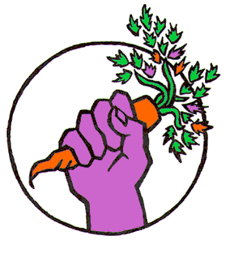
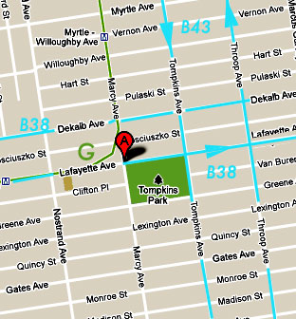

bed-stuy food not bombs

www.bedstuyfnb.org

food is a right,

not a privilege.
directions to the food share:
subway: g-train to bedford-nostrand or myrtle-willoughby.
bus: b38 west from ft. greene, clinton hill, east from bushwick, ridgewood
b43 south from williamsburg, greenpoint to tompkins & lafayette....

location: north-west corner, von king park

bed-stuy
food not bombs

email to
us at LongIslandFoodNotBombs
@gmail.com
or bsfnb@etaoin.com
or call
631-223-4370

solidarity,
not charity.

-sharing saturdays at 3PM at the corner of lafayette and marcy, outside of von king (tompkins) park.
what is
food not bombs?
other things we can share.

*a vegetarian diet is healthy for our bodies and the environment and does not exclude anyone.
*we need to take responsibility for and be engaged in our community.
other than time and involvement here are some other things we can always use…
-connections to local groups and individuals
-school supplies, paint, markers, glue, fabric, paper, etc.
-food staples such as oil, sugar, salt, spices, tea, coffee, beans, pasta, onions, garlic, vegetarian/ vegan canned goods, etc. We distribute all kinds of vegetarian food – hot, cold, canned, packaged, and bulk produce.
-cleaning supplies such as sponges, paper towels, aluminum foil, toilet paper, etc.
-cooking equipment such as blenders, food processors, pots, storage containers, cutting boards, etc.
-serving equipment such as large spoons, trays, folding tables, etc.
-tableware such as reusable and disposable bowls, plates, utensils, napkins, plastic bags, etc.
bed-stuy food not bombs is an independent chapter of food not bombs composed of members of the bed-stuy community working to improve our lives and those of our neighbors.
food not bombs is made up of hundreds of autonomous chapters sharing free vegetarian food with any/everyone. we are not affiliated with a political party and we are not a charity. we believe that there is enough food for everyone if it is distributed in a more equitable manner. food not bombs is one way that we, as members of a community, can address various social issues.
*there is an abundance of food in the world.
*everyone should have access.
*many current food production and distribution practices are wasteful and harmful to our environment.

-come and share with us at von king park on saturdays at 3.
-connect with food sources such as local restaurants, supermarkets, community gardens, coops, cafés, etc.
-help us find a kitchen or other space to meet and cook in.
-pick up food from our food sources. vehicles are urgently needed for our larger food contributions. the most crucial times are friday nights and saturday mornings. you can participate once or on an ongoing basis (no commitment required).

how can i
participate?

